**CSC 1101 – Problem Solving and Programming Laboratory**

**Warmup Lab 3b – [your name]**

**Not graded**

**a)** Save this document with your name and the lab assignment number somewhere in the file name.

**b)** Type/paste your answers into the document.

**c)** Submit this document to the Canvas item where you downloaded this document.

**//==========================================================**

**//**

**// Title: Warmup Lab 3**

**// Course: CSC 1101**

**// Lab Number: Warmup Lab 3**

**// Author: Trevor Trusty**

**// Date: 1/9/2019**

**// Description:**

**// This C++ program gets a number from the user and**

**// calculates the factorial of it.**

**//**

**//==========================================================**

**#include <conio.h> // For function getch()**

**#include <cstdlib> // For several general-purpose functions**

**#include <fstream> // For file handling**

**#include <iomanip> // For formatted output**

**#include <iostream> // For cin, cout, and system**

**#include <string> // For string data type**

**using namespace std; // So "std::cout" may be abbreviated to "cout".**

**int main()**

**{**

**// Declare variables**

**int number;**

**double fact; // Declared 'double' to hold larger numbers**

**// than 'int'**

**// Show application header**

**cout << "Welcome to Factorial Calculator" << endl;**

**cout << "-------------------------------" << endl << endl;**

**// Loop to get number.**

**// -Factorial is not defined for numbers less than 0.**

**// -double cannot hold number larger than 170!.**

**cout << "Enter a whole number to calculate the factorial "**

**<< "of (between 0 and 170): ";**

**cin >> number;**

**while (number < 0 || number > 170)**

**{**

**cout << "\nEnter a whole number to calculate the "**

**<< "factorial of (between 0 and 170): ";**

**cin >> number;**

**}**

**// Test which number entered**

**if (number == 0 || number == 1)**

**fact = 1;**

**// Calculate factorial of numbers greater than 1**

**else**

**{**

**// Loop to calculate factorial**

**fact = 1;**

**for (int i = number; i > 1; i--)**

**fact = fact * i;**

**}**

**// Show factorial**

**cout << number << "! = " << fact << endl;**

**// Show application close**

**cout << "\nEnd of Factorial Calculator" << endl << endl;**

**// Pause before application window closes**

**cout << "Press any key to exit ..." << endl;**

**_getch();**

**}**

**If possible, format your code like this:**

**Font “Courier New”**

**Font size “9”**

**Bold**

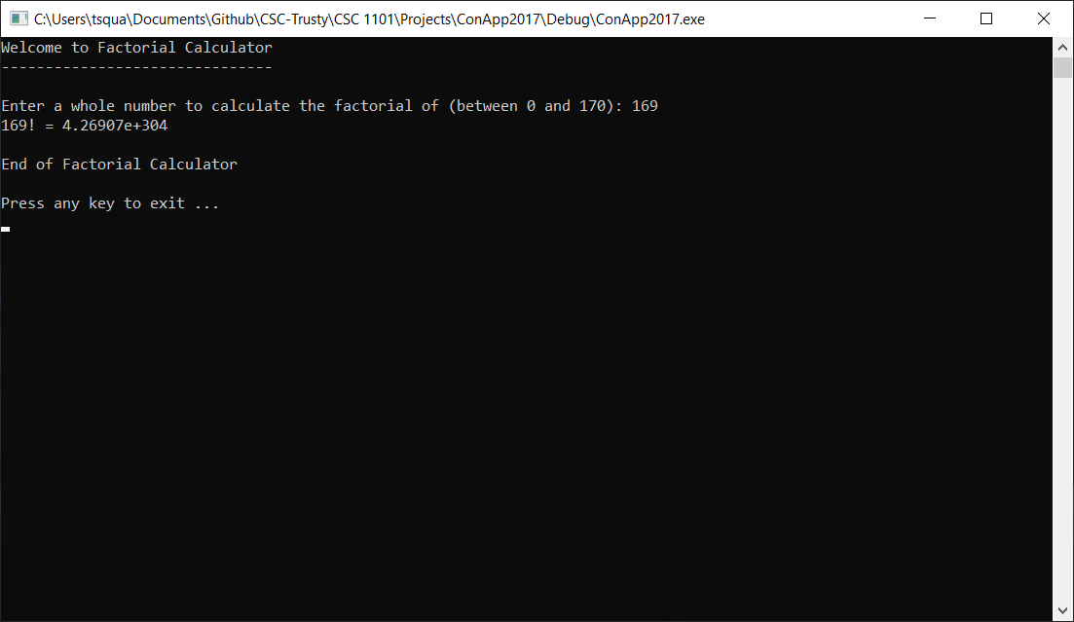

* **Copying-and-pasting Visual C++ code to a Word document**

1) From within the Visual C++ program, press **CTRL-A** and press **CTRL-C**.

2) From within the Word document, press **CTRL-V**.

** **Copying-and-pasting Visual C++ console application output to a Word document**

1) From the Visual C++ console, press **ALT-PrintScreen**.

2) From within the Word document, press **CTRL-V**.